# **GRAMMY**® **AWARD-WINNING SINGER/SONGWRITER AND ACTRESS ASHANTI DROPS "BONAFIDE SURVIVOR," DEBUT RELEASE FROM UPCOMING FEATURE FILM SOUNDTRACK**

[TODAY'S RELEASE MARKS LAST DROP BEFORE LONG-AWAITED DEBUT ALBUM OUT FEB 21](https://www.noaddressmovie.com/soundtrack)

RED STREET RECORDS OFFICIALLY PARTNERS WITH ROBERT CRAIG FILMS ON THE RELEASE OF OFFICIAL MOTION PICTURE SOUNDTRACK AND ACCOMPANYING FILM SCORE ALBUM

[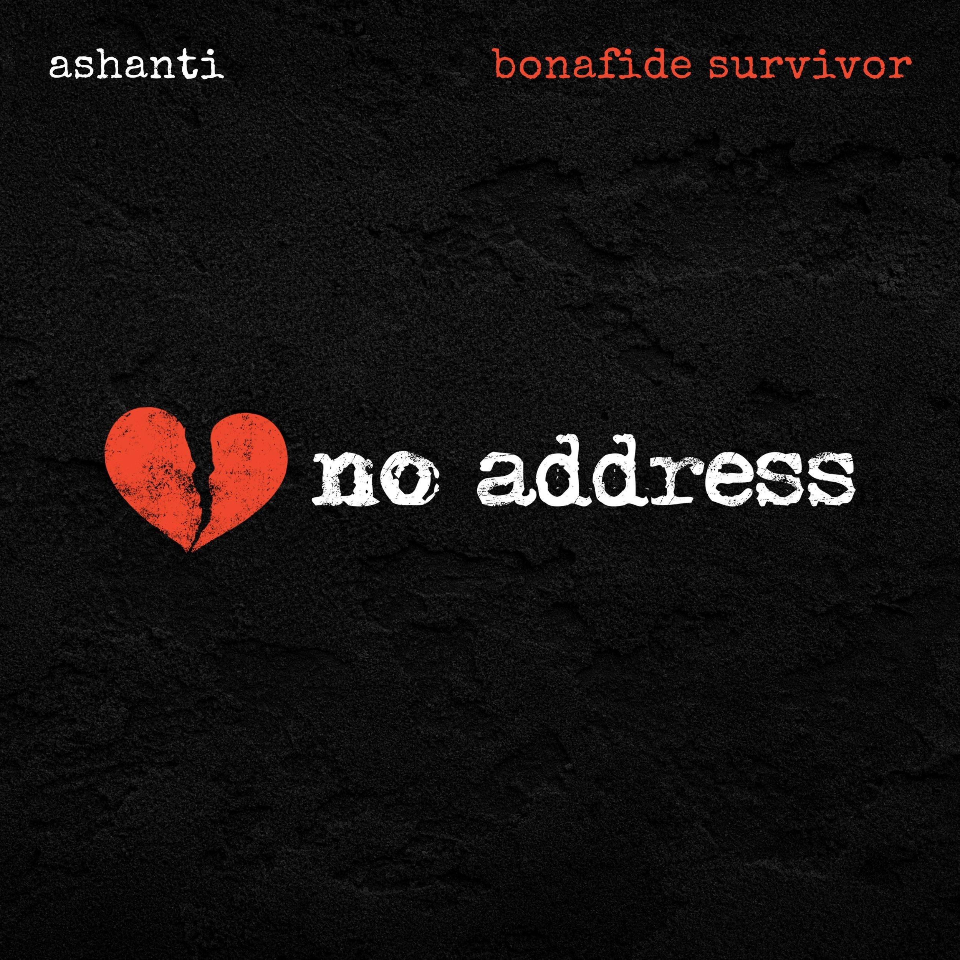](https://www.noaddressmovie.com/soundtrack)

**February 7, 2025 – Nashville, TN:** GRAMMY® Award-winning and #1-charting singer/songwriter and actress, Ashanti, released her track, "Bonafide Survivor" today ([STREAM HERE](https://www.noaddressmovie.com/soundtrack)), serving as the debut release of the upcoming soundtrack for feature film, *No Address*. Starring Ashanti, an executive producer on the project, William Baldwin, Xander Berkeley, Ty Pennington and others, *No Address* is a gripping journey of living without walls and rising above them. The film, produced by Robert Craig Films and distributed by Fathom Entertainment, hits theaters nationwide on February 28 ([TICKETS](https://t.e2ma.net/click/mkbqyj/6n3ho9yb/uug71w)) and offers a cinematic exploration of hope, humanity, and resilience, reminding us to never stop believing in hope and the unstoppable human spirit. ([OFFICIAL TRAILER](https://www.noaddressmovie.com/)).

[](https://www.noaddressmovie.com/soundtrack)

Written by Ashanti and produced by Warryn Campbell, today's "Bonafide Survivor" drops as a companion to the official video ([WATCH HERE](https://t.e2ma.net/click/mkbqyj/6n3ho9yb/m0j71w)) and tees up the full [*No Address* studio soundtrack](https://www.noaddressmovie.com/soundtrack), out February 21st.

**Full Album Tracklisting**

“Trouble Magnet” - **Merripennie**

“You Don’t Fight this Alone” - **Christian Anderson Band**

“Skin Deep” - **Ryan Griffin**

“Daylight” - **Raquel Cole & Todd Tilghman**

“Bonafide Survivor - **Ashanti**

“Broken” - **Ron Artist II**

“Lost & Found” - **Chynna & Vaughan**

“Pain Has A Purpose” - **Rachael Lampa**

“The Worlds Better Cause You’re In It” - **Alexander Pappas**

“Where You Are” - **Montell Jordan (feat. Tedashii)**

“Do Better” - **Fred Hammond**

TO STREAM "BONAFIDE SURVIVOR*,"*[CLICK HERE](https://www.noaddressmovie.com/soundtrack).

TO WATCH THE OFFICIAL *NO ADDRESS* TRAILER,[CLICK HERE](https://www.noaddressmovie.com).

TO PURCHASE TICKETS TO SEE *NO ADDRESS* IN A THEATER NEAR YOU,[CLICK HERE](http://fathomentertainment.com/events/no-address/).

**ABOUT ASHANTI:** Ashanti is a GRAMMY® Award-winning singer/songwriter, actor and author, who burst onto the music scene with her smash hit, self-titled debut album Ashanti. The album landed the #1 spot on both the Billboard Top 200 and R&B album charts, selling a whopping 504,593 units in its first week and set a SoundScan record as the most albums sold by any debut female artist in the chart’s history, granting her a spot in the Guinness Book of World Records, which she still holds today. Ashanti has released six studio albums and received eight Billboard Awards, a GRAMMY, two American Music Awards, two Soul Train Awards, six ASCAP Awards, and many more awards and illustrious honors. Ashanti has continued to reign at the top as one of Billboard’s “Top Females of the Decade from 2000-2010” and continues to break Billboard records as having a Hot 100 entry in the 2000’s, 2010’s and 2020’s. To celebrate her contributions to music and recording, Ashanti received a star on the Hollywood Walk of Fame on April 7, 2022. [Download Press Image Here](https://www.dropbox.com/scl/fi/0xxn9glv9st9qz8c7h7ge/AshantiHeadshot.jpg?rlkey=p36wkkhqv08j1u9larsew9ho4&st=qhs42qb9&dl=0)

**ABOUT NO ADDRESS MOVIE:** Homeless at 17, Lauren lost everything—except the will to survive. On the streets, she finds new meaning in a family of outcasts and discovers that home is where the hope is. No Address is a gripping journey of living without walls and rising above them. Starring Lucas Jade Zumann, Beverly D’Angelo, Isabella Ferreira, William Baldwin, Ty Pennington, Kristannna Loken, Patricia Velasquez, and Ashanti, this powerful film dares you to believe in second chances. Get tickets & learn more at: [NoAddressMovie.com](http://noaddressmovie.com).

**ABOUT ROBERT CRAIG FILMS:** Based in California, Robert Craig Films develops, creates, and produces films that inspire audiences to engage with greater empathy, compassion, and generosity in the communities they live in. The company's mission is to create impactful films that spark meaningful conversations and drive social change. Visit [www.RobertCraigFilms.com](http://www.robertcraigfilms.com) for more information.

**CONTACT:**

***Brooklyn Gould-Bradbury Robert Craig Films***

[Brooklynn.G@RedStreetRecords.com](mailto:Brooklynn.G@RedStreetRecords.com) [Hello@RobertCraigFilms.com](mailto:Hello@RobertCraigFilms.com)

253.282.2125