**ROBERT CRAIG FILMS UNVEILS OFFICIAL TRAILER**

**AND KEY ART FOR DEBUT FEATURE FILM *NO ADDRESS* FROM FATHOM ENTERTAINMENT IN THEATERS FEBRUARY 28**

***Groundbreaking Film Commits 50% of Net Profits to***

***Combat Homelessness in Local Communities Nationwide***

***A Powerful Exploration of Homelessness and Humanity***

***Featuring an All-Star Cast***

[**Fathom Entertainment Now Offering Tickets On Sale**](http://www.noaddressmovie.com)

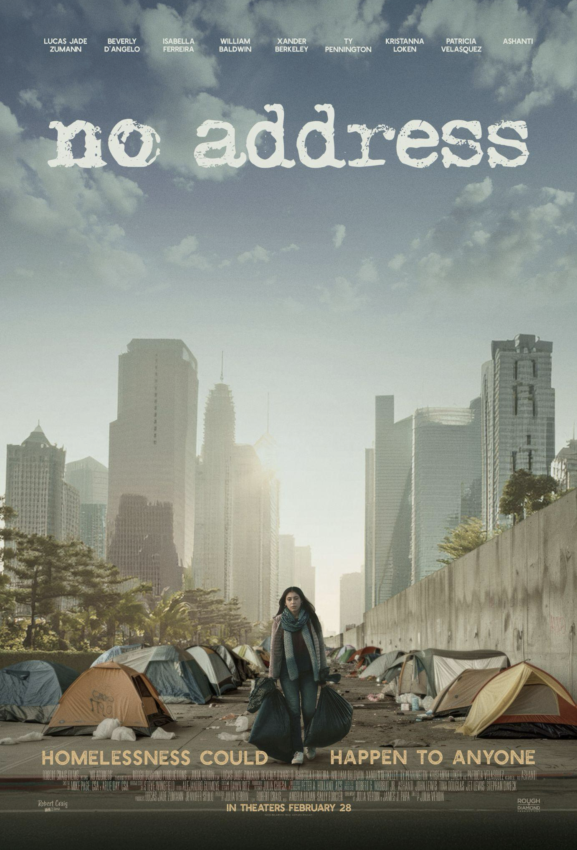

**January 21, 2025 – Sacramento, CA:** Robert Craig Films unveiled the official trailer and key art today for its upcoming debut feature film, ***NO ADDRESS***, in theatres nationwide and presented by Fathom Entertainment beginning February 28. ***NO ADDRESS*** follows the harrowing journey of Lauren, a young woman pushed onto the streets and forced to survive against all odds. Alongside a makeshift family of outcasts—each with their own haunting story of struggle and loss—Lauren discovers that home is not just a place, but the people who refuse to let you fall.

Featuring powerhouse performances from Lucas Jade Zumann (*20th Century Women*, *Anne with an E, Chicago Fire*), Beverly D’Angelo (*National Lampoon’s Christmas Vacation*, *Entourage, Vegas Vacation*), Isabella Ferreira (*Crush, Love Victor, Orange is the New Black*), William Baldwin (*Gossip Girl, Parenthood, Forgetting Sarah Marshall*), Xander Berkeley (*Terminator 2: Judgment Day, The Walking Dead, 24*), Ty Pennington (*Extreme Home Makeover: Home Edition, Trading Spaces*), Kristanna Loken (*Terminator 3, Boy Meets World*), Patricia Velasquez (*The Mummy, The Mummy Returns, Arrested Development*) and GRAMMY® Award-Winning Singer/Songwriter & actress, Ashanti (*Coach Carter, John Tucker Must Die*), ***NO ADDRESS*** s is a raw and unflinching look at the dark realities of homelessness.

Watch the trailer [here](https://youtu.be/K3ZWGuCY8-Q).

***NO ADDRESS*** is directed by Julia Verdin (*Maya, Americans With No Address*) and with producers Jennifer Stolo and Lucas Jade Zumann, and produced by Robert Craig, Angela Lujan, Sally Forcier and Julia Verdin.

Robert Craig Films is deeply committed to addressing the urgent issue of homelessness and has pledged to donate 50% of net profits from the feature film to a wide range of organizations and churches that are working tirelessly to combat the homelessness cycle within their communities.

The film is complemented by a soundtrack with original songs from Ashanti, Ryan Griffin, Montell Jordan, Rachel Lampa, and various other artists, set to be released on February 21st by Red Street Records. Additionally, there is a novel, an interactive study guide, and a documentary all designed to inspire action and foster empathy. Learn more at [NoAddressMovie.com](http://noaddressmovie.com).

Experience the year’s most inspiring movie event that reminds us to never stop believing in hope and the unstoppable human spirit. Tickets for ***NO ADDRESS*** can be purchased online [HERE](https://www.noaddressmovie.com) and at participating theater box offices. A complete list of theatres can be found at the Fathom Events website.

TO WATCH THE OFFICIAL ***NO ADDRESS*** TRAILER,[CLICK HERE](https://www.noaddressmovie.com).

TO PURCHASE TICKETS TO SEE ***NO ADDRESS***IN A THEATER NEAR YOU,[CLICK HERE](http://fathomentertainment.com/events/no-address/).

TO DOWNLOAD THE OFFICIAL KEY ART & PRESS MATERIALS, [CLICK HERE](https://www.noaddressmovie.com/press).

#

**ABOUT *NO ADDRESS* MOVIE:** Homeless at 17, Lauren lost everything—except the will to survive. On the streets, she finds new meaning in a family of outcasts and discovers that home is where the hope is. ***NO ADDRESS*** is a gripping journey of living without walls and rising above them. Starring Lucas Jade Zumann, Beverly D’Angelo, Isabella Ferreira, William Baldwin, Ty Pennington, Kristannna Loken, Patricia Velasquez, and Ashanti, this powerful film dares you to believe in second chances. Get tickets & learn more at: [NoAddressMovie.com](http://noaddressmovie.com).

**ABOUT ROBERT CRAIG FILMS:** Based in California, Robert Craig Films develops, creates, and produces films that inspire audiences to engage with greater empathy, compassion, and generosity in the communities they live in. The company's mission is to create impactful films that spark meaningful conversations and drive social change. Visit [www.RobertCraigFilms.com](http://www.robertcraigfilms.com) for more information.

**ABOUT FATHOM ENTERTAINMENT:** Fathom Entertainment is the leading global specialty distributor of live and pre-recorded content to theatres. For more than 20 years, Fathom has pioneered theatrical distribution of events and special engagements, including performing arts, movies, episodic content, and other special event programming across various genres and formats. Fathom offers content creators a worldwide cinema distribution network by operating in 45 countries and boasts a live digital broadcast network of more than 1,100 locations. Fathom is owned by AMC Entertainment Inc. (NYSE: AMC), Cinemark Holdings, Inc. (NYSE: CNK), and Regal Cineworld Group (LSE: CINE.L). For more information, visit [FathomEntertainment.com](http://fathomentertainment.com).

**CONTACT:**

***Nicole Crumbley, EPIC Agency Robert Craig Films***

[Nicole@Epic.Inc](mailto:Nicole@Epic.Inc) [Hello@RobertCraigFilms.com](mailto:Hello@RobertCraigFilms.com)

770.286.1144