# 

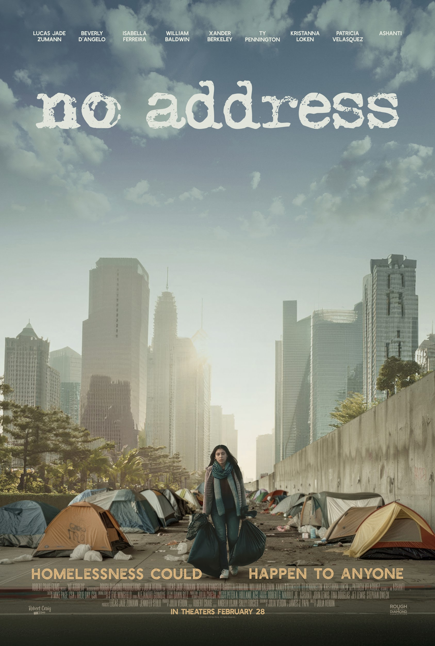

**Robert Craig Films Presents *NO ADDRESS***

**Coming to Digital & On Demand April 4, 2025**

**PRESS ROOM ASSETS:**

* [Audio Book Announcement](https://www.noaddressmovie.com/press) (March 19, 2025)
* [Official Trailer & Key Art Announcement](https://www.noaddressmovie.com/press) (January 21, 2025)
* [Ashanti’s “Bonafide Survivor” Debut Release](https://www.noaddressmovie.com/press) (February 7, 2025)
* [Official Key Art](https://www.noaddressmovie.com/press)
* [Official Trailer Embed Code](https://www.noaddressmovie.com/press)
* [Approved Stills](https://www.noaddressmovie.com/press)
* **\*Clips available upon request\***

**OFFICIAL WEBSITE & SOCIAL MEDIA:**

* Website: [https://www.NoAddressMovie.com](https://www.noaddressmovie.com/)
* Facebook: [https://www.facebook.com/NoAddressMovie](https://www.facebook.com/NoAddressMovie/)
* Tik Tok: [https://www.tiktok.com/@NoAddressMovie](https://www.tiktok.com/@noaddressmovie)
* Instagram: [https://www.instagram.com/NoAddressMovie](https://www.instagram.com/noaddressmovie/)
* Youtube: <https://www.youtube.com/@NoAddressMovie>
* X: [https://x.com/NoAddressMovie](https://x.com/noaddressmovie)

**MOVIE OVERVIEW (*Short Synopsis*):**

Homeless at 17, Lauren lost everything — except the will to survive. On the streets, she finds new meaning in a family of outcasts and discovers that home is where the hope is.

***NO ADDRESS***  is a gripping journey of living without walls and rising above them.

Starring Lucas Jade Zumann, Beverly D’Angelo, Isabella Ferreira, William Baldwin, Xander Berkeley, Ty Pennington, Kristannna Loken, Patricia Velasquez, and Ashanti, this powerful film dares you to believe in second chances. Join the movement & learn more at: [NoAddressMovie.com](http://www.noaddressmovie.com/).

**TALKING POINTS:**

* Robert Craig Films’ first feature film, ***NO ADDRESS***, arrives on digital & on demand April 4, 2025.
* Homelessness could happen to anyone. ***NO ADDRESS***  is a gripping journey of living without walls and rising above them.
* Inspired by true events, ***NO ADDRESS*** follows the harrowing journey of Lauren, a young woman pushed onto the streets and forced to survive against all odds.
* Alongside a makeshift family of outcasts—each with their own haunting story of struggle and loss—Lauren discovers that home is not just a place, but the people who refuse to let you fall.
* This powerful film dares you to believe in second chances.
* Robert Craig FIlms is using the power of film to inspire action in local communities nationwide. Robert Craig Films will donate 50% of net profits from the film and its suite of resources to nonprofit organizations and churches that are working tirelessly to combat homelessness within their communities.
* Experience the year’s most inspiring movie event that reminds us to never stop believing in hope and the unstoppable human spirit.
* Join the movement & learn more: [**NoAddressMovie.com**](http://www.noaddressmovie.com/)

**SUGGESTED INTERVIEW QUESTIONS:**

1. Why is it important to share untold stories of those experiencing homelessness?
2. This project pledges to donate 50% of net profits to organizations fighting homelessness. What does that commitment mean to you?
3. The synopsis highlights “Home is where the hope is”... What does that phrase represent for you personally? (Home is not just a place, but the people who refuse to let you fall.)
4. How does the film challenge common perceptions about homelessness?
5. What do you hope viewers will take away from this movie?
6. What impact do you hope the movie will have on organizations and communities working on homelessness?
7. Can you talk about a moment during filming that made you reflect on the realities of homelessness?
8. What has been the most rewarding part of being involved in a project that focuses on empathy and compassion?
9. Where can people go to find out more information about the movie?

**HEADSHOTS AND BIOS:**

**ASHANTI:**

* **CHYRON:** GRAMMY® Award-winning singer/songwriter and Actress in ***NO ADDRESS***
* **HEADSHOT:** [**LINK**](https://drive.google.com/file/d/18-gGKqLPlmwfKj0nUYFNIEuzyPsbI2ek/view?usp=sharing)
* **BIO:** [**LINK**](https://docs.google.com/document/d/1r_VedKaXEd4NSmHWzCKW01ztJrJuvzWk/edit?usp=sharing&ouid=108362283980996174847&rtpof=true&sd=true)

**WILLIAM “BILLY” BALDWIN:**

* Name should be written as “William” - spoken to as “Billy”
* **CHYRON:** William Baldwin; Actor in ***NO ADDRESS***
* **HEADSHOT:** [**LINK**](https://drive.google.com/file/d/14Bu1-qBtUCWs93AE56dCaxGNJ4YuBfDp/view?usp=sharing)
* **BIO:** [**LINK**](https://docs.google.com/document/d/1TnpKxGArrNK-8C33nVP7UCQ7n-fCptmI/edit?usp=sharing&ouid=104041189333774712521&rtpof=true&sd=true)

**TY PENNINGTON:**

* **CHYRON:** Actor in ***NO ADDRESS***
* **HEADSHOT:** [**LINK**](https://drive.google.com/file/d/1bSA49IGU-khVCbZA7tY2mcmoGeFtNPTX/view?usp=sharing)
* **BIO:** Ty has three Primetime Emmy Awards and is a New York Times best-selling author. You know him as the sensational TV host from Extreme Makeover, Trading Spaces and many others.

**XANDER BERKELEY:**

* **CHYRON:** Actor in ***NO ADDRESS***
* **HEADSHOT:** [**LINK**](https://drive.google.com/file/d/1avGWDJPf_GWMCiRpofXOX2mzkxAVUHa2/view?usp=sharing)
* **BIO:** You know him from Terminator 2 with Arnold Schwarzenegger, Air Force One with Harrison Ford, Shanghai Noon with Jackie Chan, Apollo 13 with Tom Hanks, Taken with Liam Neeson, A Few Good Men with Tom Cruise, Gattaca and numerous other movies. He's been in an amazing 125 titles for television including 24 with Kiefer Sutherland and The Walking Dead. He's also part of the upcoming 3rd season of Apple's hit crime anthology series, Truth Be Told.

**LUCAS JADE ZUMANN:**

* **CHYRON:** Actor and Producer in ***NO ADDRESS***
* **HEADSHOT:** [**LINK**](https://drive.google.com/file/d/1C6VZmNa57CGIKSDi4NiGr-s4I-VBZxMS/view?usp=sharing)
* **BIO:** Lucas is known for Anne With an E with Amybeth McNulty, 20th Century Women with Annette Bening (the film also received an Oscar Nominee for best screenplay at the Academy Awards), Every Day with Angourie Rice and Sinister 2 with Shannyn Sossamon.

**JULIA VERDIN:**

* **CHYRON:** Writer and Director in ***NO ADDRESS***
* **HEADSHOT:** [**LINK**](https://drive.google.com/file/d/1k4Ml9L4hNZkQbt06RUPfqEtcP79Lk5kW/view?usp=sharing)
* **BIO:** [**LINK**](https://docs.google.com/document/d/1vpIAO3EWkE191AXoa3oJUL7SndEM-Ih5/edit?usp=sharing&ouid=104041189333774712521&rtpof=true&sd=true)